# Simulating the inner planets of the Solar System using Beeman Algorithm

## Introduction

In this project I have created a simulation of the inner plants of the solar system. The aim was to create a realistic simulation in order to perform experiments and see if the results match the real world. The experiments I implemented were “Satellite to Mars” and “Asteroids and doomsday”.

There are multiple ways to get a satellite to Mars, but I decided on using a ‘Hohmann Transfer Orbit’ in which a satellite is put into an elliptical orbit fired from Earth such that the aphelion of the orbit crosses the path of Mars. However Mars needs to be at the correct angle from Earth, so that when the satellite is at aphelion, Mars is at its closest. The aim of the experiment therefore was to try launching satellites at Mars at different angles within a range of the theoretical angle and calculate a closest approach that the satellite was to Mars.

For the Asteroid simulation I wanted to see how likely it is for an asteroid to encounter Earth. Meaning that asteroids would be randomly placed into the simulation, and I would track the distances from Earth to see if any came close.

The so-called ‘doomsday’ scenario occurs when all planets are aligned in a row. In this simulation I wanted to see how often the planets would align to within a given tolerance. To measure the time that the planets would align I ran the simulation with different tolerances to see if the value would change.

To make sure the simulation was also working correctly I wanted to track the total energy of the system, by summing all the kinetic energy of the planets as well as their gravitational potential energy at each timestep and tracking this value to make sure it remained constant. I also calculated the relative orbital periods of the planets in the simulation, to make sure they would match reality.

## Methods

### Planet Class

The Idea behind this class is to simply to create an object to create to represent a planet. It contains all necessary fields to hold all the data related to planet i.e. mass, position and velocity. The class contains no methods, since its used more of just a storage system/ abstract representation of a real world object.

### Solar Class

The purpose of this class is to hold the entire simulation. I decided to separate the simulation itself from any experiments that could be run on it. This meant that I could instantiate a simulation any number of times. The idea of this meant that each experiment could be run in its own environment which would allow for a greater control over variables. For example I didn’t want asteroids flying around while I was trying to get the satellite to Mars. Therefore within this class I have all necessary methods required to calculate the next positions and velocities of the planets using the Beeman Algorithm as well as for executing an entire timestep. This class also includes the methods for animating the simulation. The animation is completed ‘on the fly’, meaning that the a timestep is executed and immediately the results are displayed on screen as opposed to animating precompiled results. The advantage of this is that the simulation can run indefinitely, but it meant that I had to remove the animation when running the experiments, otherwise they would take too long to complete.

Within thin class I also included two class methods to convert between radians and degrees. This means that they can be used by other programs without the Solar class being instantiated.

### Experiments

#### Satellite to Mars

In this experiment I am investigating the ideal angle at which to launch a satellite to Mars using the Hohmann transfer orbit. Firstly I needed to calculate the orbital parameters of the orbit. I have shown the formulas I used in Appendix 1. In order for the experiment to work properly I placed the satellite on the opposite side of the Earth to ensure that gravity from Earth wasn’t a factor. The ideal angle calculated was Mars being 44.3 degrees in from of Earth. Therefore I decided to run 20 simulations with angles from 30 degrees to 50 degrees. To ensure an even spread of values. To calculate the angle between the planets. I thought simply using the dot product formula would suffice, however this would not show if Mars was in front or Earth or not. Therefore I had calculate their clockwise angles relative to the x-axis. Therefore the angle is calculated the angle to the x-axis of Mars from Earth. Due to the precision of floating point numbers I rounded the angles to 3 decimal places so that the values could be compared for equality. The data for the experiment was recorded by appending data to a text log file, and appending the raw data of the angle and the closest approach to Mars to a csv file.

To launch a probe I created a method which takes as a parameter an angle at which to launch. Firstly I run the simulation for two years as asked by the question. Then continued to run the simulation until the angle between Mars and Earth is equal to the angle passed in, offset by 180 degrees since I’m launching the probe on the opposite side. Once the angle is the same I create and new Planet Object to represent the probe and append it to self.sim.planets so that it is part of the simulation. Next I continue running the simulation, but I calculate the distance between Mars and the probe and keep track of the lowest value ‘Closest Approach’ which is then logged to the data files. The simulation is run for one complete orbit of the probe to ensure that the closest approach is contained within the simulation.

#### Asteroids

This experiment was designed to investigate how likely it is for Earth to be hit by an asteroid. I designed the simulation such that an asteroid would be generated within a given probability and with a random position and velocity (reasonable values) to the simulation. Each timestep I would measure the distances between the asteroids and Earth to check if any were coming close. If any were within a given distance, this would be logged as a close encounter. The output of the simulation is a text document which contains the log of the entire experiment showing each asteroid creation as well as if there were any close encounters.

To initialise the experiment I initialised the number of asteroids to zero, the name of the log file as well as a simulation. The experiment is then run through the ‘runAsteroidSimulation’ method, which requires as parameters an integer for the number of years for which the simulation is run as well as a probability for the likelihood of an asteroid to be created, which is a float between 0-1.

A close encounter is defined as an asteroid that is closer than 1018 meters. This was chosen as it means that a close encounter is quite likely and can be seen on the log file as well as being a distance such that it reasonably close to earth to be of interest.

I have two methods to create two NumPy arrays for position and velocity. I decided for a maximum velocity of 50,000 m/s and a position range to be defined as the maximum distance from the farthest Planet i.e. Mars. This means that all the asteroids defined are likely to have quite eccentric orbits around the sun, meaning that encounters with the Earth are more likely.

The method add asteroid is used to create a planet object with the random velocity and position calculated using the methods mentioned before. Also asteroids are typically have a mass of 2.8 – 3.2 1021 kg, so I choose a random mass within this range and set the colour to grey. This planet object with the name ‘asteroid’ is then added to the simulation list of planets.

#### Doomsday

For the doomsday scenario I wanted to see how often the planets would come to one and other within a tolerance of a certain angle in order to see how often the so called ‘doomsday’ scenario happens when the planets align in a row. To check if the planets were aligned I created the method isAligned to return True if the planets were all aligned within the given tolerance, otherwise it would return False. The angle that each planet makes with each other relative to the sun has to be less than the tolerance in order for them to be classed as aligned.

The runSimulation() method is responsible for running and individual experiment for each tolerance. In this method I run the simulation for a year to misalign the planets initially. Then continue running timesteps until they are aligned. I then then log the result from the experiment to a log file. The experiment was run with multiple different angles to see if a narrower alignment angle was less likely to happen.

#### Orbital Periods

In this experiment I want to check that the orbital periods of the planets in my simulation match the orbital periods of planets in real life. To do this I use Kepler’s 3rd law of motion to calculate the orbital period from it’s distance from the sun. The output of the experiment was again written to a log file.

#### Energy Conservation

Here I want to check that my simulation is working correctly by calculating the total energy of the simulation at each timestep. Since energy is conserved, if I calculate the total energy of the simulation by summing the kinetic and gravitational energy for each planet I should see that it remains constant.

## Results

### Hohmann Transfer (Mars Experiment)

To calculate the parameters of the Hohmann Orbit I used the formulas in Appendix 1. Calcuating the orbital period of the transfer was 518 days. Taking half of this number since we want to know the time to get to Mars is 259 days. According to NASA’s website the Viking Probe was launched August 20th and was put into a circular obit around Mars on 19th June 1976; resulting in a total flight time of 305 days. Similarly calculating for the ideal launch angle was 44.3 degrees. From the results you can see that a very slight change in launch angle results in a huge

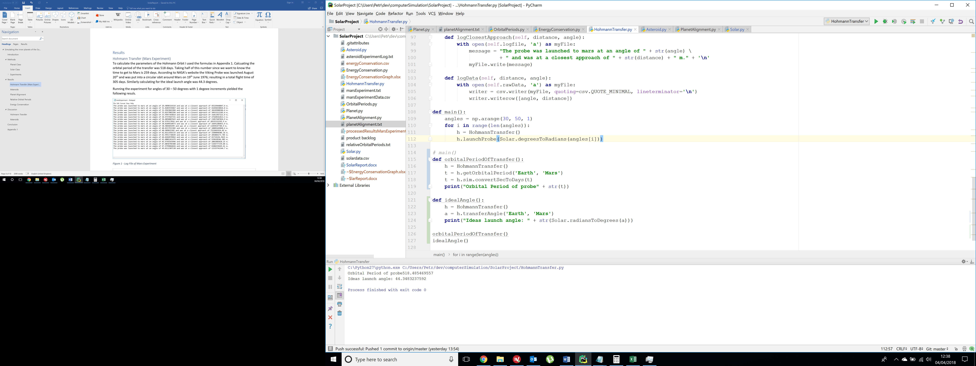

Figure 1 - Orbital Parameters returned from Simulation

Running the experiment for angles of 30 – 50 degrees with 1 degeee increments yielded the following resuls.

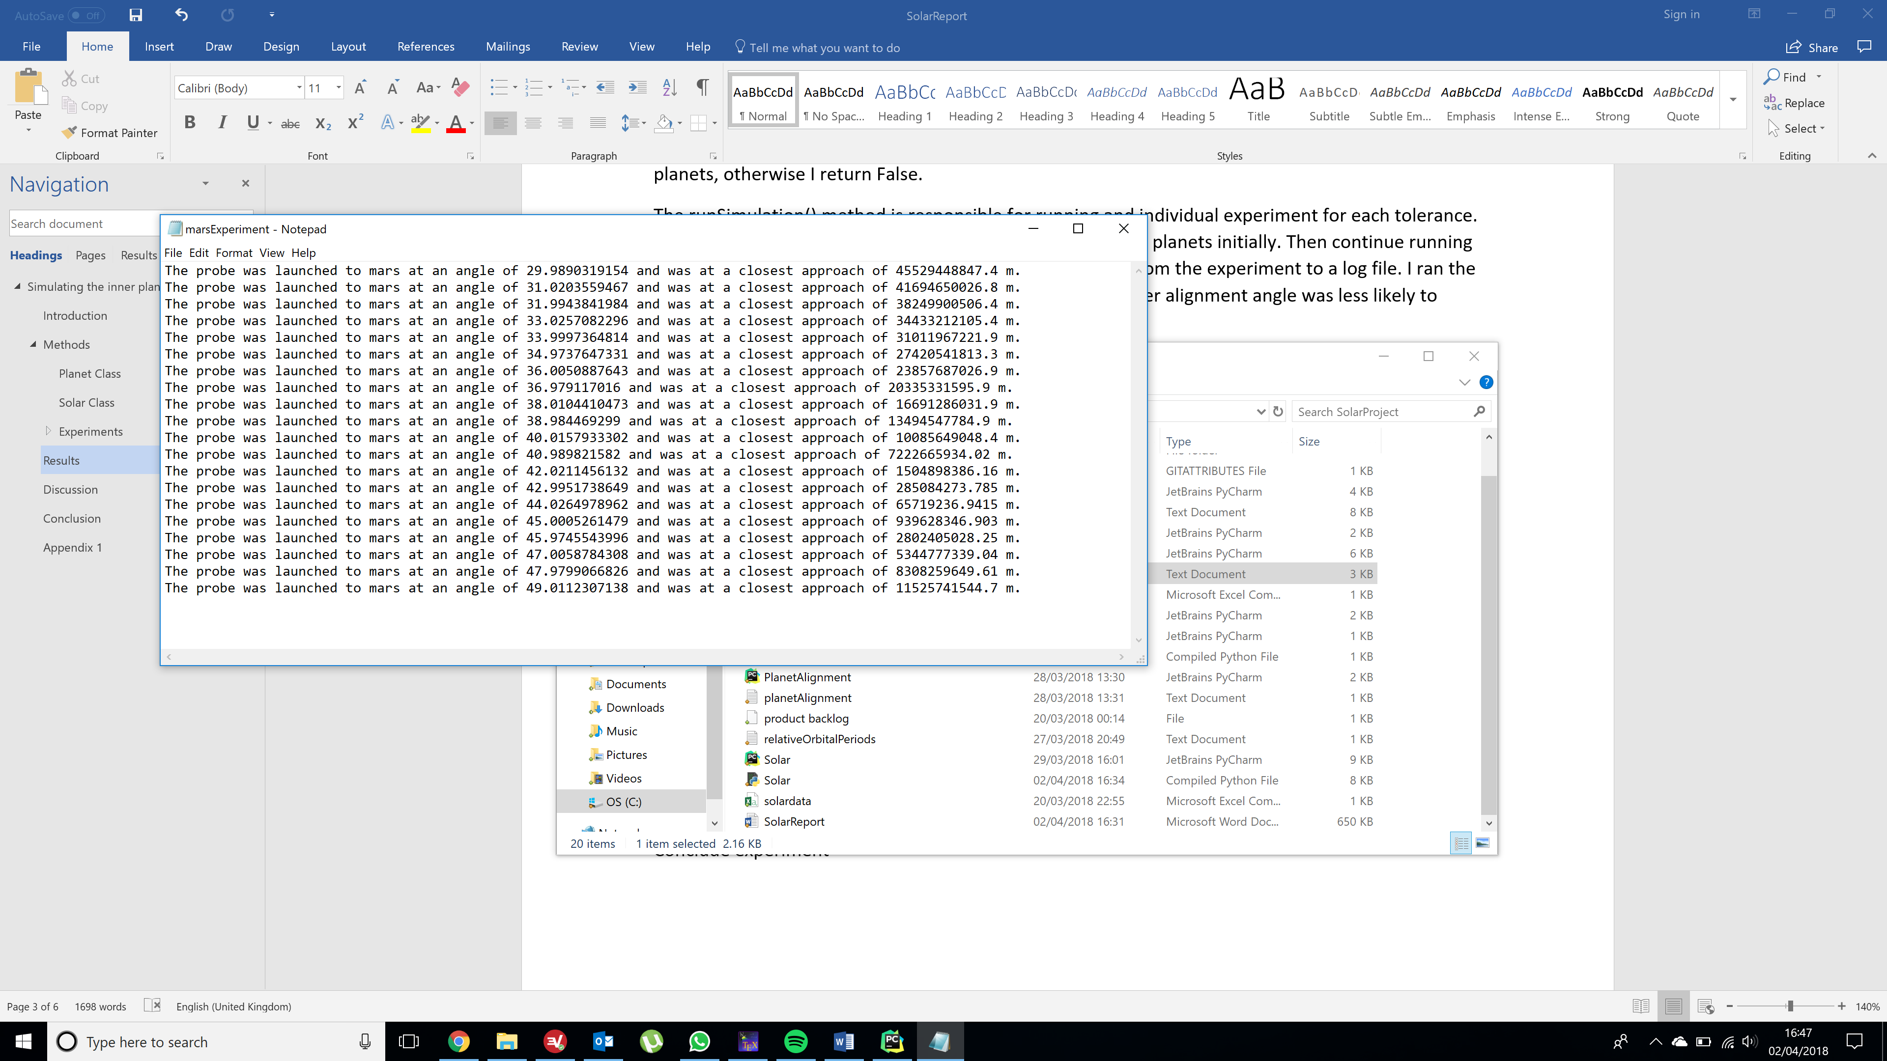

Figure 2 - Log File of Mars Experiment

Figure 3 - Graph of results from Mars Experiment

From Figure 3 you can clearly see that the lowest value for closest approach was when the angle was 44 degrees. At this angle the probe came to a closest approach of 65,700 km of Mars. A geostationary orbit around mars is at a distance of 17,000 km[1], therefore a value of 65,700 is very respectable for a flypast. From the graph you can see, that even a few degrees difference in launch angle results in a huge distance from Mars. This suggests that the launch window is extremely narrow. It is also highly likely that if a probe is to be launched to Mars, that it performs several corrective manoeuvres along it’s journey to correct its trajectory in order to get itself as close as possible to Mars to perform a flypast. Corrective burns will also be necessary since Mars’ orbit is elliptical, not circular as was the assumption for calculating the Hohmann Transfer.

### Asteroids

The Asteroid simulation was run for four years, with a probability asteroid creation of 0.1. The experimental log is quite long so I have included a snapshot.

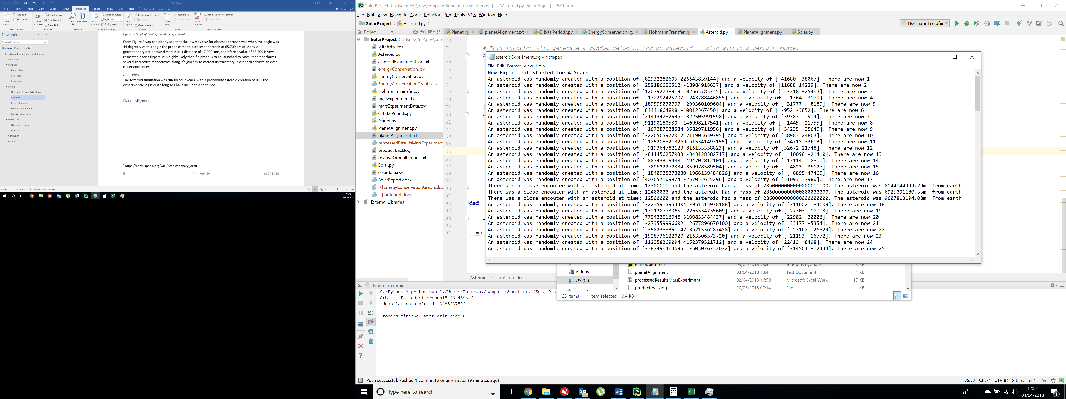

Figure 4 - Asteroid Experiment Log

The results show that two encounters did occur. The first was an encounter of an asteroid that came to a closest approach of 6.9 million kilometres, and the second had a close encounter of 1.7 million kilometres. In total over the course of the simulation 136 asteroids were created.

Even if we take the closest value of the approach and compare it to the diameter of the Earth which is 12,700 km, this asteroid is still 134 times the radius of the Earth distance away. This means that there is still an extremely low likelihood for an impact to occur.

Due to the inefficiencies of this simulation, it does not provide enough data to allow for a good approximation of the likelihood of impact. The probability that any particular asteroid will actually hit Earth is the fraction of the asteroids orbits that would lead to an impact over the total number of asteroids. Say if there are one million total asteroids, and one of those leads to an impact, then we can conclude that the odds of the asteroid hitting the Earth are one in a million. But because the simulation struggles with even 100 asteroids at once, it is unfeasible to achieve such a result without modifying the code.

### Planet Alignment

I ran the experiment with a range of tolerance angles from 10 degrees to 20 degrees.

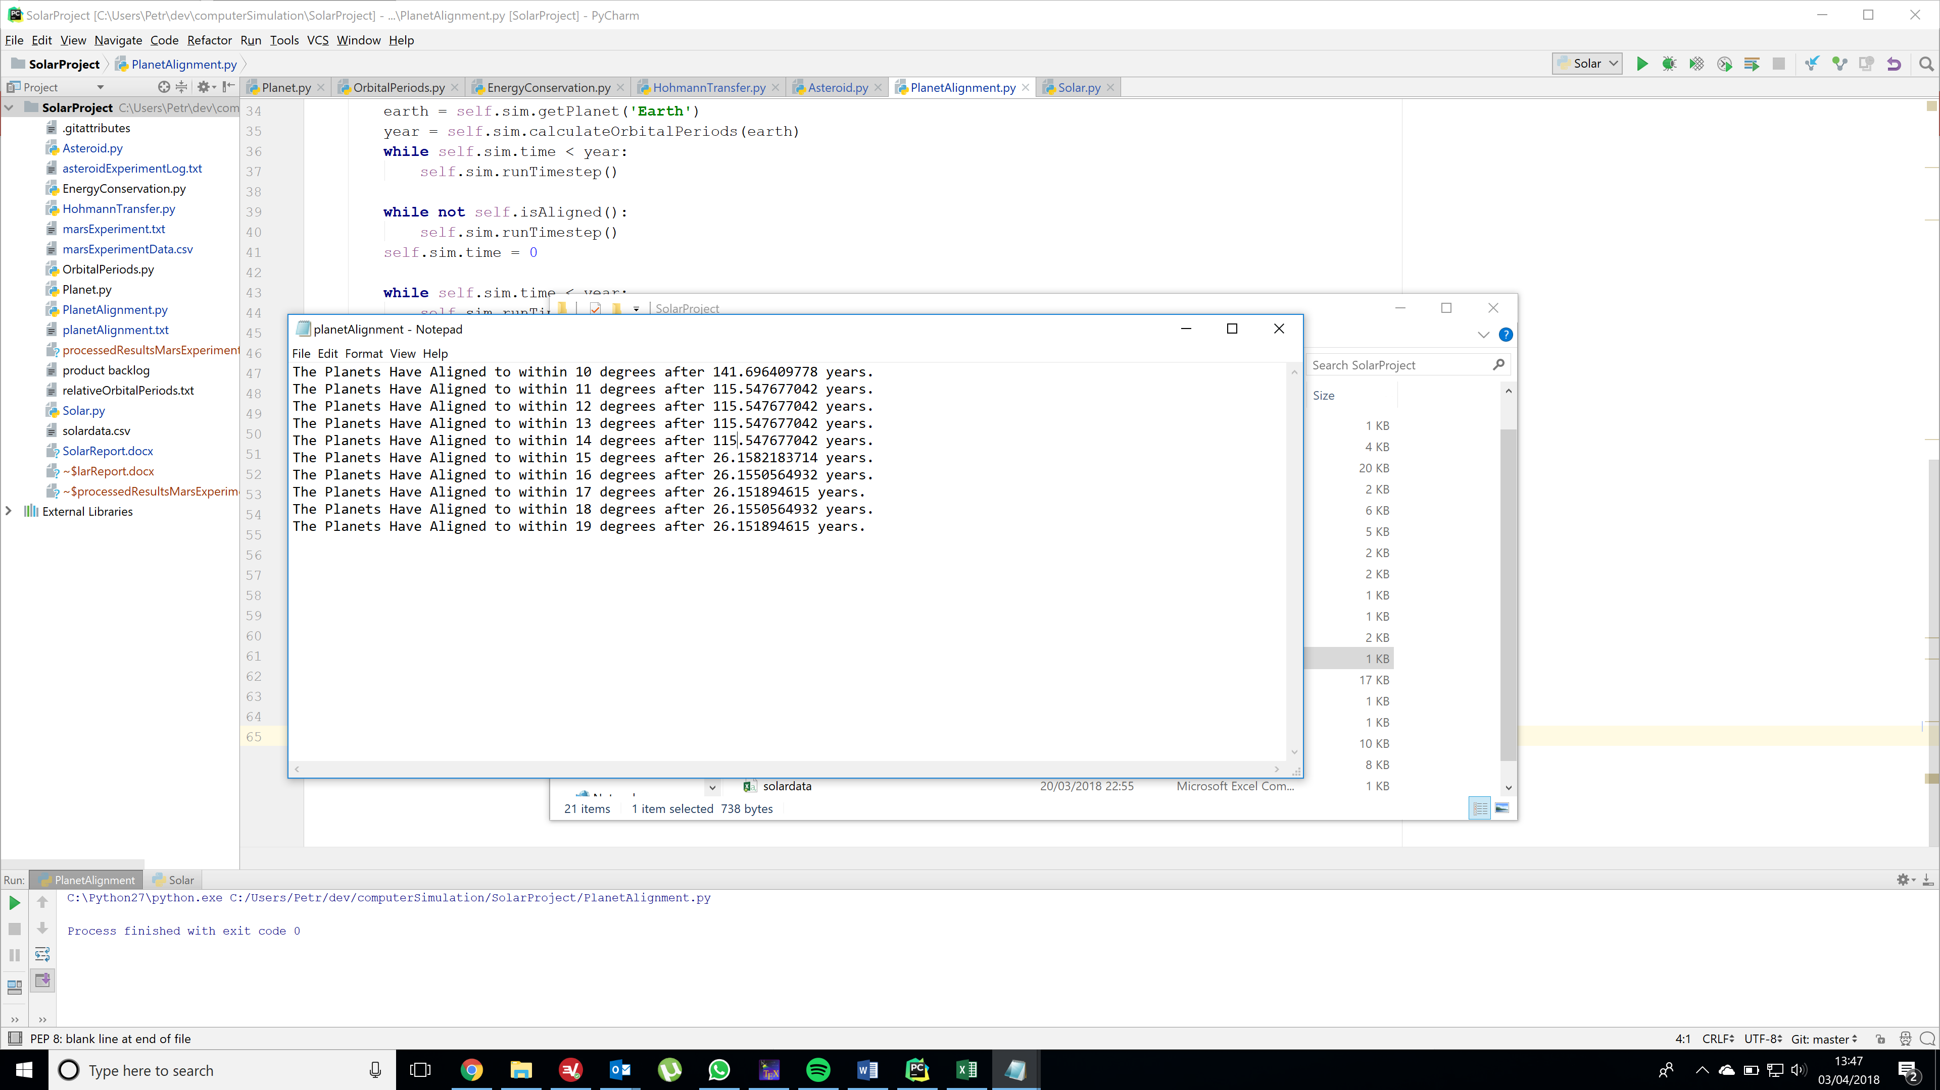

Figure 5 - Log Data from Planet Alignment Experiment

From the results you can clearly see that there are 3 distinct time scales on which alignments happen (142, 115 and 26 years). Although these alignments are uncommon, they do however happen regularly and within reasonable timescales. Although the idea that a seemingly coincidental alignment of planets can possibly have some sort of influence of doom is false, it is interesting to find that these planetary alignment do happen more frequently than first expected. Also alignments between a few planets are extremely common and are used by Astronomers to get higher detailed pictures of planets because they are relatively closer to the Earth.

### Relative Orbital Periods

Running the simulation experiment yielded the following results written to a log file.

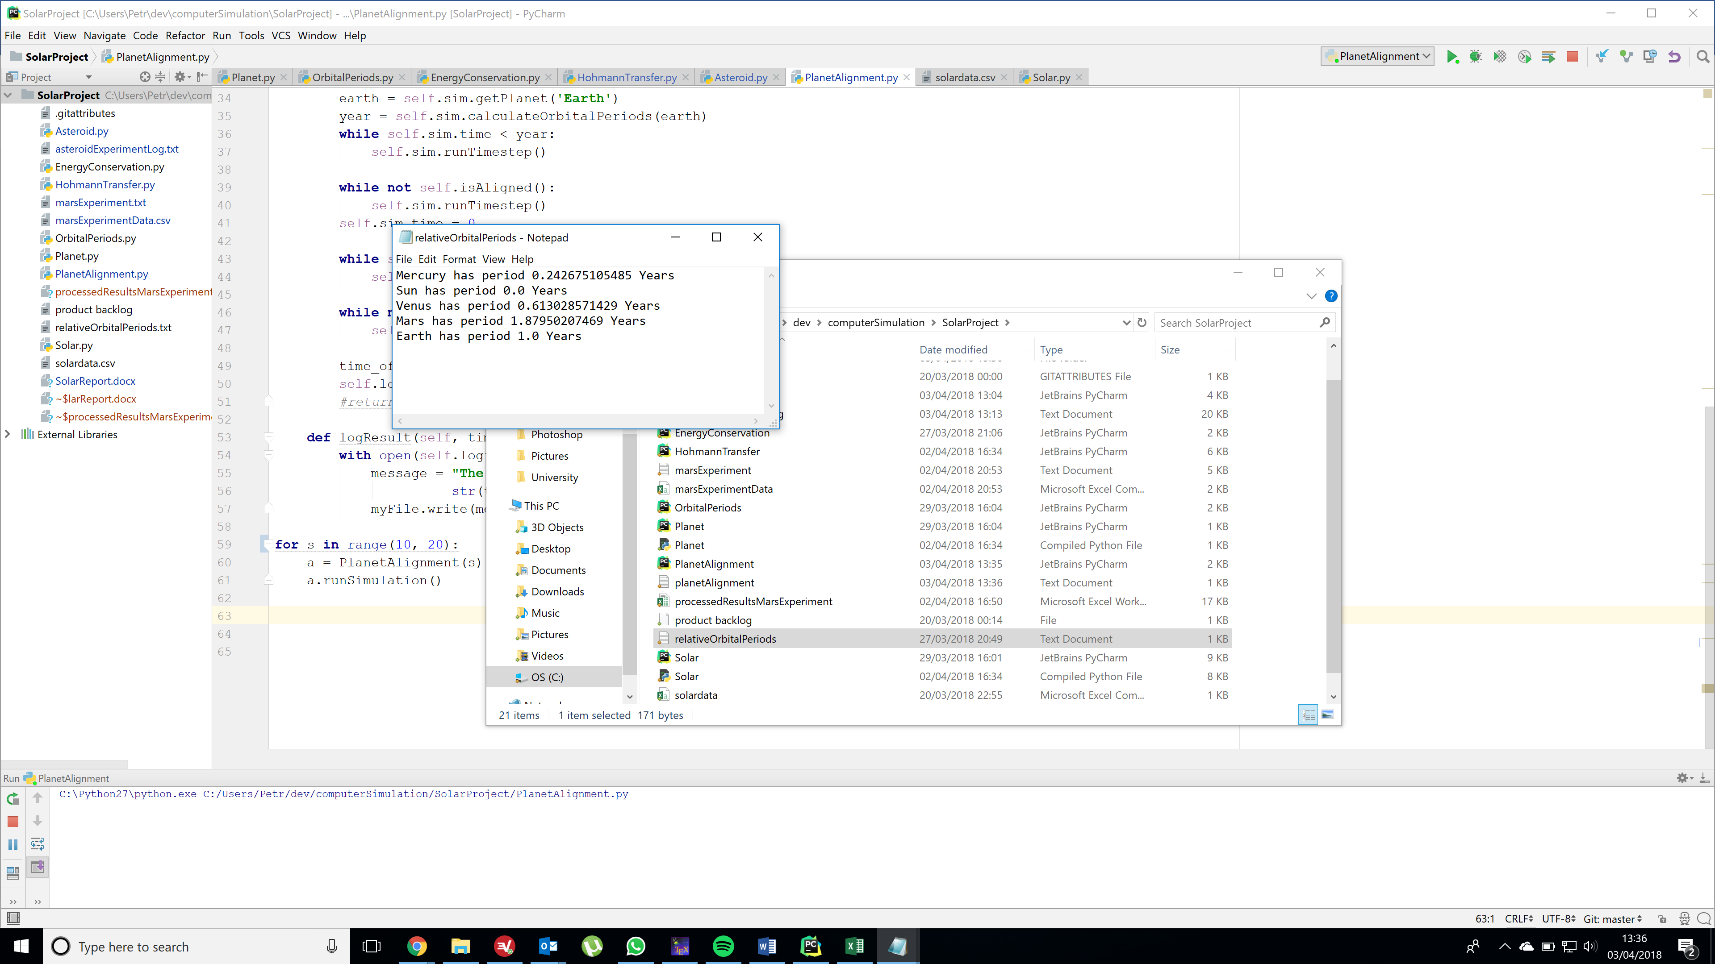

Figure 6 - Orbital Periods of planets in Earth Years

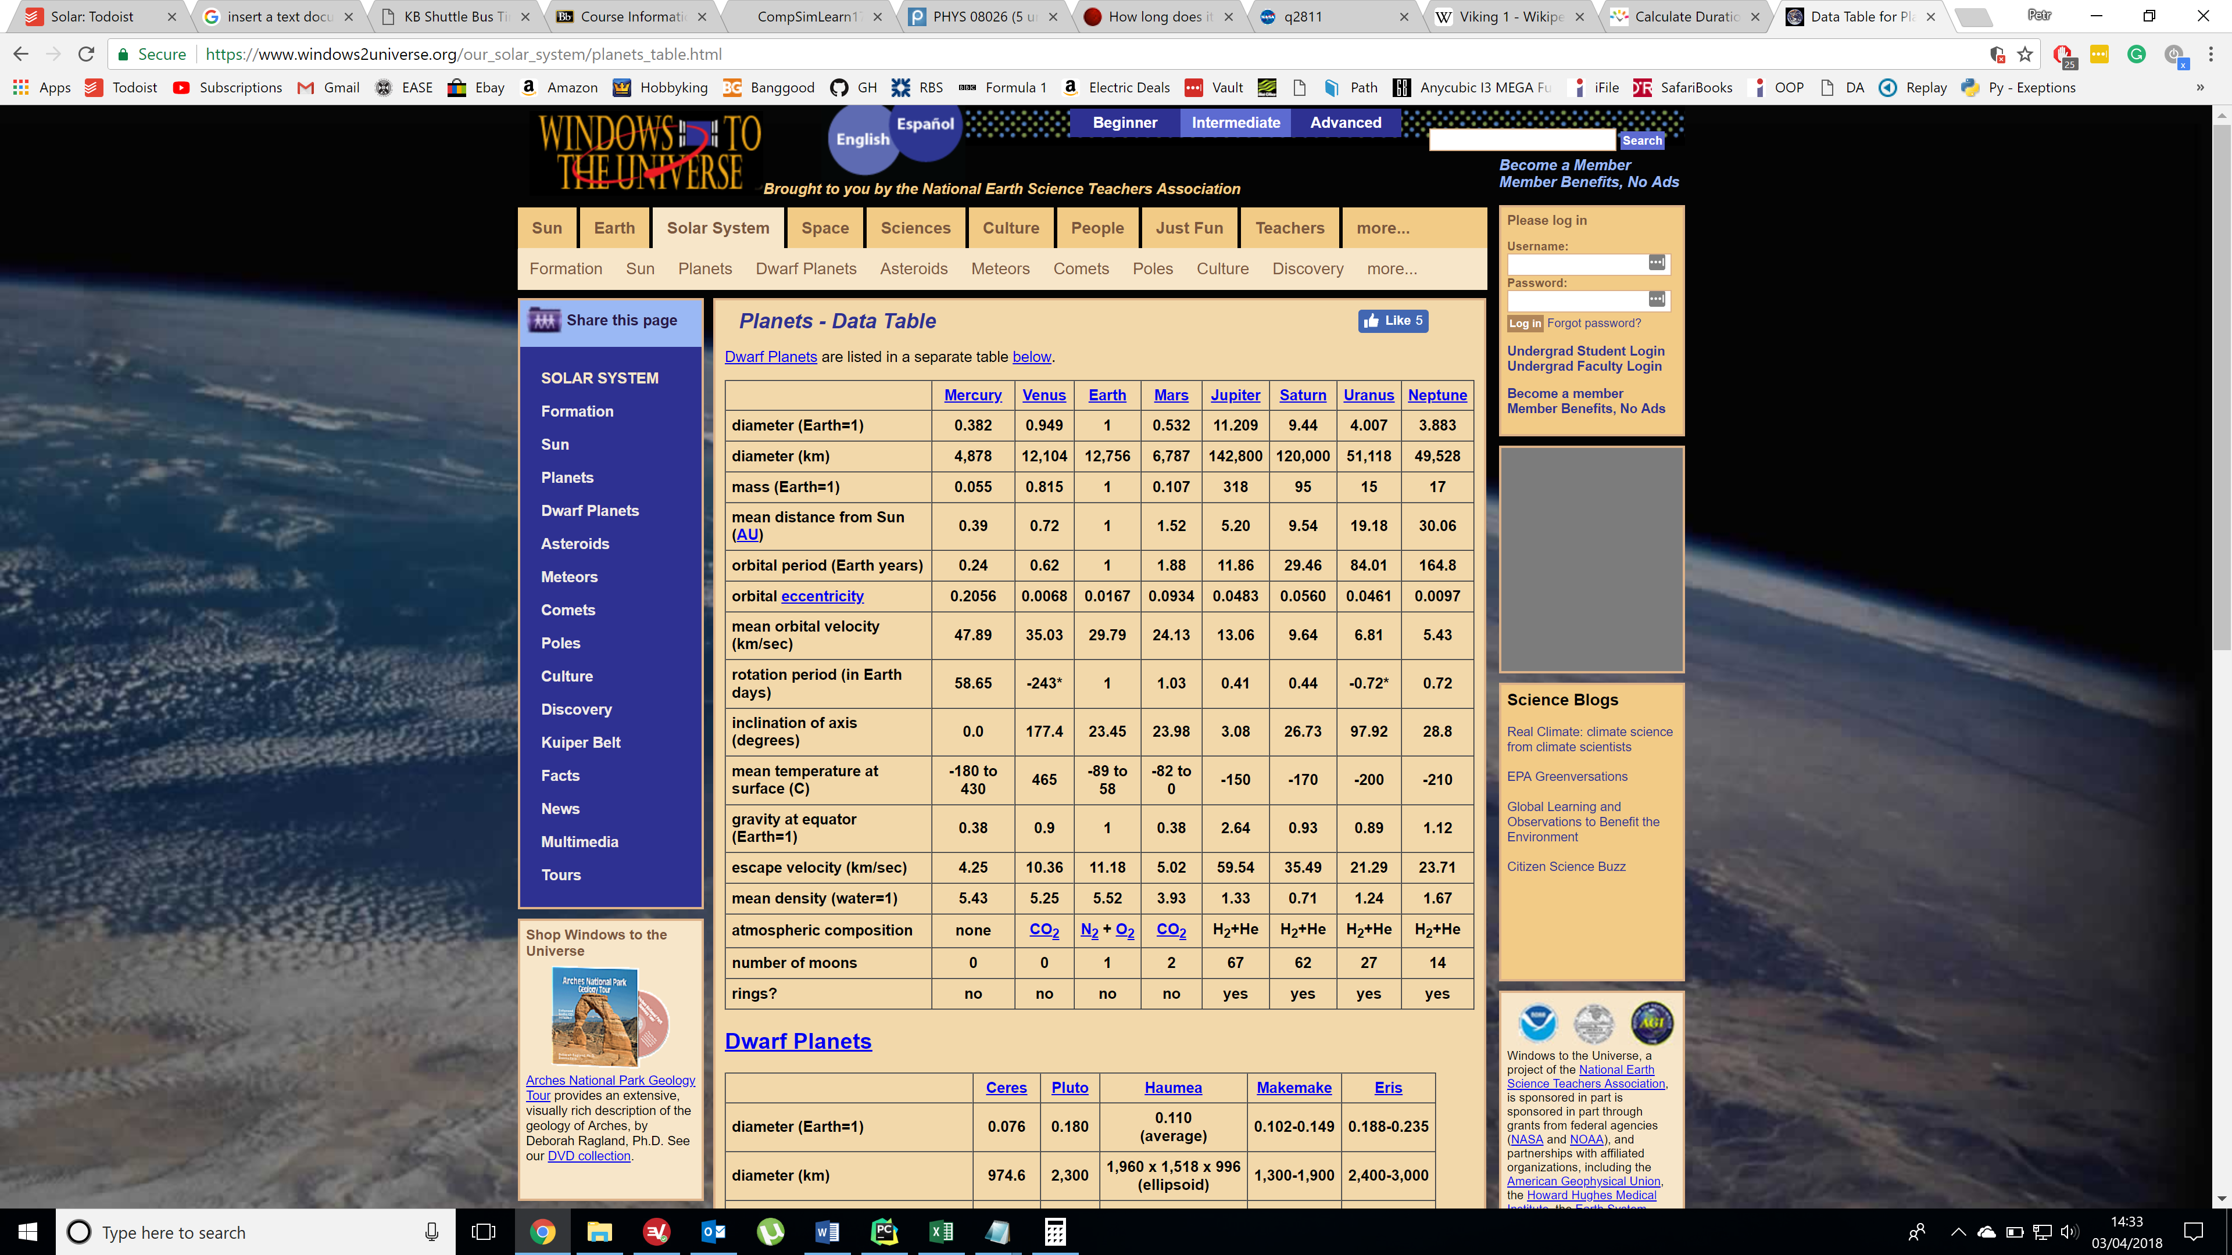

Figure 7 - Real World Orbital Periods (<https://www.windows2universe.org/our_solar_system/planets_table.html>)

As you can see the results obtained are as expected. This is not altogether unexpected as I used real world data to initialise the position and velocity of planets in the simulation. However the simulation still yields real world results.

### Energy Conservation

I logged the total energy of the simulation by summing the kinetic energy of all the planets and the gravitational potential energy from the sun for each planet. Figure 6 shows how the total energy oscillates over time, however taking the average of this function shows that it remains constant.

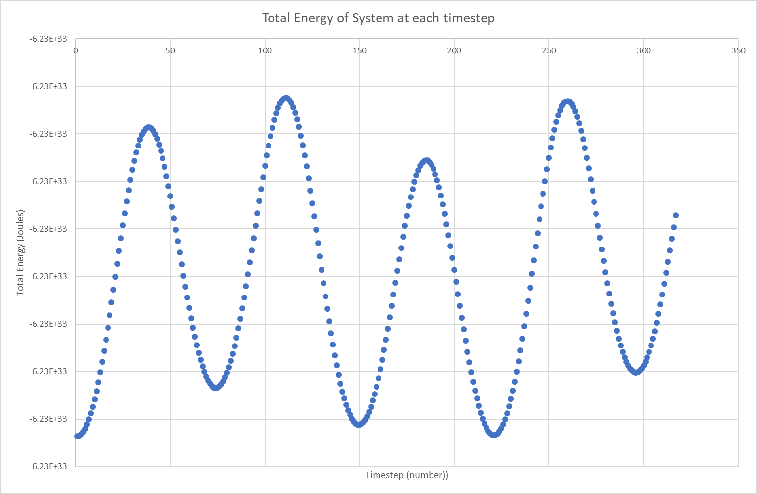

Figure 8 - Total Energy of Simulation at Each Timestep

## Discussion

### Hohmann Transfer

The Hohmann Transfer can also include a secondary burn to put the probe into a circular orbit around the sun when it reaches Mars. This manoeuvre could also be added to the simulation to try and simulate a full mission to the planet Mars as well as a manoeuvre to bring the probe back to Earth. The results from the experiment clearly show the minimum distance occurring at 44 degrees. However since the simulation takes some time to computer I decided to use integer values for the angle. Ideally I would use angles with a greater precision in order to fully show that the ideal angle is correct at 44.3 degrees.

### Asteroids

Due to the compute time of this simulation running large data sets for this simulation is impractical. The experiment was only run for 4 years with only 139 asteroid created and it still took a few minutes to complete. To really get a accurate idea of how likely an asteroid impact is, would require many million asteroid paths to be simulated. However the data still shows that asteroids can come close to Earth, but the likelihood of any of them hitting the earth are extremely small. This because even smaller if we consider the real world which is three dimensional. Meaning that the likelihood of impact becomes even smaller.

### Doomsday

From the data you can see that the greater the tolerance angle, the shorter the time taken for alignment to happen. The results obtained are reliable, however the simulation was only run for once occurrence of alignment. The issue is that alignment may not be evenly distributed. For example you could have 2 alignments happen within a short time, but the next alignment might take a lot longer to occur. To calculate a mean value for when alignments can happen, I would run the simulation until maybe 10 alignments have happened. From this I can then extrapolate the mean value for alignments occurring. However due to the necessary compute time with this simulator, this isn’t possible.

## Conclusion

In conclusion the simulation of the Solar System proved to be realistic, as the results from the experiments match real world data. Probably the most successful experiment, the Hohmann Transfer, verifying a very close result and showing a very close encounter to Mars of just 65,000 km. Also the simulation showed the same relative orbital times of the planets around the Sun as the real world. Calculating the total energy of the system shows that it remains constant through the experiment, although with some small fluctuations, showing that Conergy was conserved as you would expect in the real world. The asteroid simulation proved the most challenging to get a realistic result, simply due to the rarity of asteroid impacts with the Earth and the length of compute time it would take to see such an occurrence.

## Appendix 1





1. https://en.wikipedia.org/wiki/Areostationary_orbit